HD 145675 (14 Her)

HD 145675 is a 0.9 M☉, K0 V star1. Based on 148 RV HIRES measurements obtained between 1997 and 2019 and 127 RV Apf measurements obtained between 2014 and 2018, the CL survey reported a GP (HD 145675b) signal with a period of days, a minimum mass of MJup and an eccentricity of as well as a LPGP (HD 145675c) with a period days, a minimum mass of MJup and an eccentricity of .

In the present study, in addition to the CL survey’s dataset, 111 RV ELODIE measurements obtained between 1994 and 2006 and 52 RV SOPHIE measurements obtained between 2008 and 2015 were used. DPASS and MCMC (1000 walkers and 400000 iterations) were used to fit the data. The properties found for HD 145675b reported in the CL survey were within the error bars associated with the values found in the present analysis. For HD 145675c, a period of 11421 days, a minimum mass of 3.3 MJup and an eccentricity of 0.19 were found with DPASS, with a corresponding rms of residuals of 6.2 m/s, and a period between 18500 and 100200 days, a minimum mass between 4.5 and 9.8 MJup and an eccentricity between 0.32 and 0.75were found using MCMC. Yet, as the RV curve of HD 145675c covers only a maximum, the period (or *a*) and the stellar offset are not well constrained.

To explore the range of possible values, the semi-major axis was fixed to different values and the data fitted with DPASS. *a* up to 110 au do not significantly change the rms of the residuals (6.8 m/s against 6.2 m/s with *a* left free). In this case (referred to as constrained *a*), the minimum mass is 4.4 MJup and the extremely high eccentricity is 0.92.

To test the impact of the stellar RV offset, it was also fixed to different values and the data, once corrected for the instrumental offsets for clarity purposes, were fitted with DPASS. It appears that stellar RV offset up to 65 m/s does not significantly change the rms of the residuals (6.8 m/s against 6.2 m/s with stellar RV offset left free). In this case (referred to as constrained offset), the semi-major axis is 14 au, the minimum mass is 13.2 MJup and the eccentricity is 0.54. The fits are shown in Fig 1, and the corner plot in Fig 2, and the results summarized in Table 1.

Note that, recently, combining RV and Hipparcos/Gaia absolute astrometry data, a study performed in 20222 (hereafter F22) reported orbital parameters close to those of the CL survey for HD 145675b and were able to estimate the orbital inclination of the planet at °, and thus a true mass of MJup. For HD 145675c, they found a period of days, an eccentricity of , an inclination of °, and a mass of MJup. Yet, as the available RV data do not allow to properly constrain the properties of HD 145674c. The uncertainties obtained on the period of the planet are probably underestimated, as for the CL survey solution. The true mass estimated by F22 can therefore not be confirmed.

Conclusion: The properties found in the CL survey of HD 145675c are not confirmed. Additional data are needed to further constrain its orbital properties.

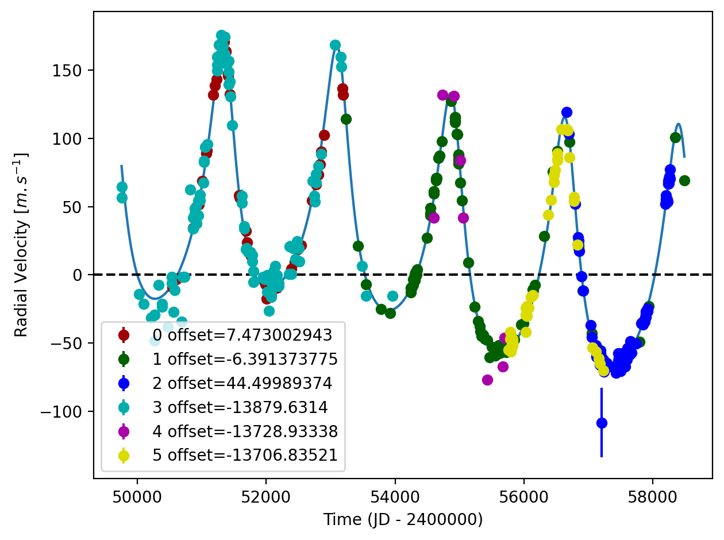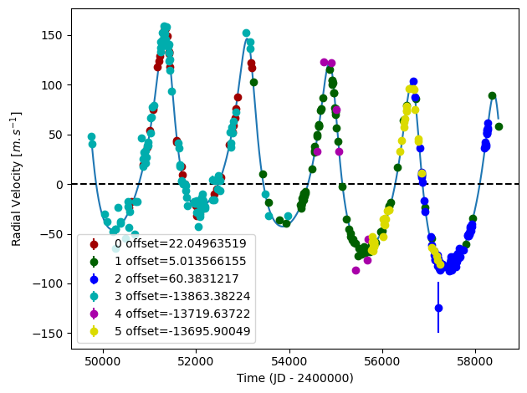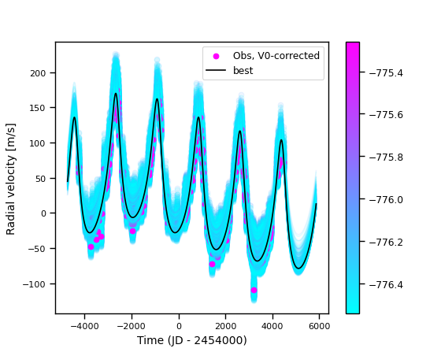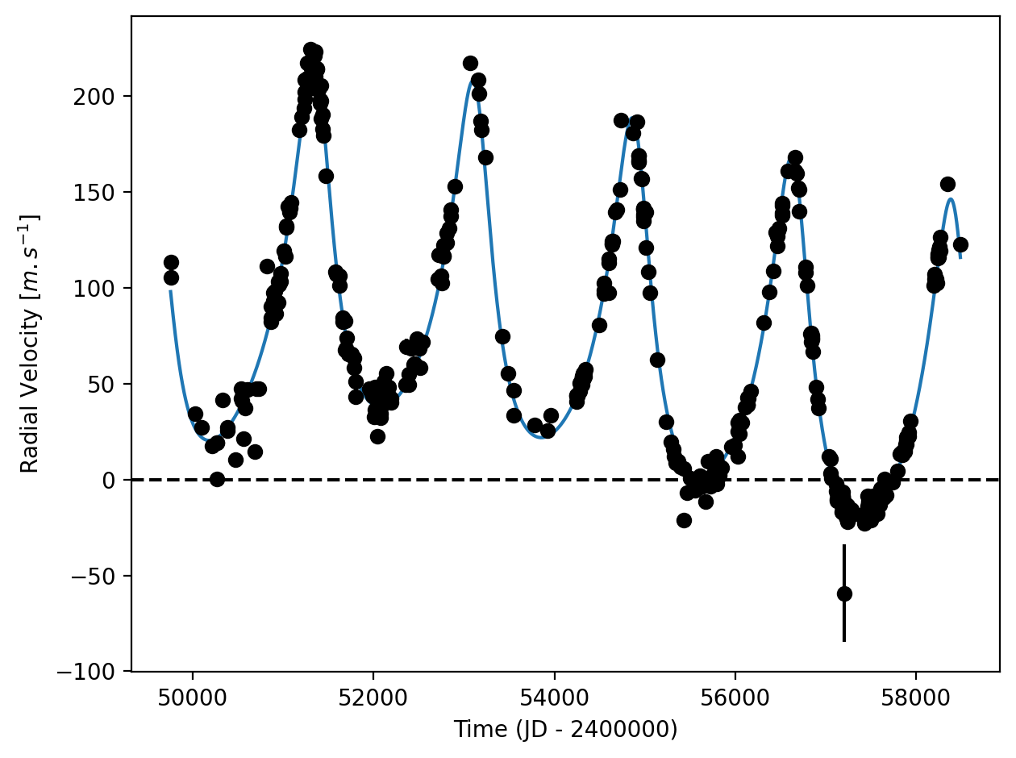

Figure 1: Top left: fit of the HD 145675 RV with DPASS. Red - Hir94, green - Hir04, blue - Apf, cyan - ELODIE, purple - SOPHIE, yellow - SOPHIE+. The blue curve shows the best fit. Top right: fit of the HD 145675 RV with DPASS, with the minimum *a* fixed at 110 au. The points are the same as on the left. The blue curve shows the best fit. Bottom left: fit of the HD 145675 RV with DPASS, with a subtracted stellar RV offset fixed to 65 m/s. Black points correspond to the data corrected for the instrumental offsets. The blue curve shows the best fit. Bottom right: fit of the HD 145675 RV using MCMC. The black curve shows the best fit. The colorbar corresponds to the log-likelihood of the fits.

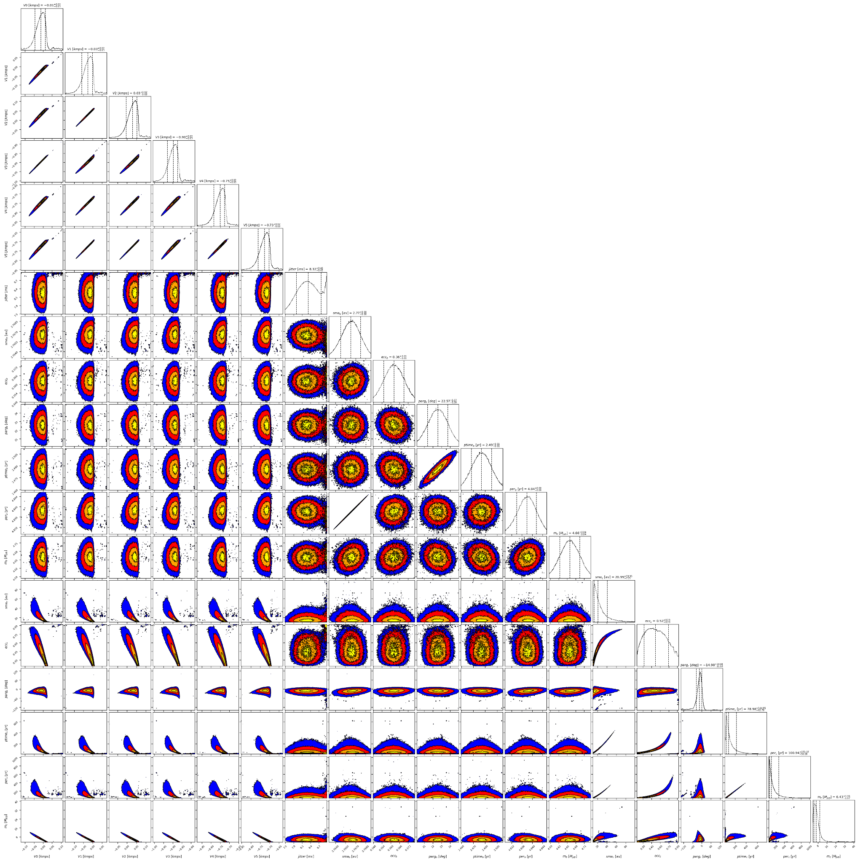

Figure 2: Corner plot of posteriors for the two-planets model MCMC fit of HD 145675 RV data.

| Parameter | Priors | | | | Posteriors | | | | CL survey |
| --- | --- | --- | --- | --- | --- | --- | --- | --- | --- |
|  | DPASS | |  | MCMC | DPASS | |  | MCMC |  |
|  | Free priors | Constrained *a* | Constrained offset | Free priors | Free priors | Constrained *a* | Constrained offset | Free priors |  |
| *a* (au) | b: [0,100]  c: [5,100] | b: [0,100]  c: up to 155 | b: [0,5]  c: [5,300] | b: [1,3]  c: [1,500] | b = 2.8  c = 9.6 | b = 2.8  c = 110 | b = 2.8  c = 14 | b = 2.77±0.01  c = 13 – 41 | b =  c = |
| Msin(i) (MJup) | b: [0,100]  c: [0,100] | b: [0,100]  c: [0,100] | b: [0,10]  c: [0,100] | b: [0.1,10]  c: [0.1,100] | b = 4.6  c = 3.3 | b = 4.7  c = 4.4 | b = 4.6  c = 13.2 | b = 4.66±0.04  c = 4.5 – 9.8 | b =  c = |
| Eccentricity | b: [0,0.95]  c: [0,0.95] | b: [0,0.95]  c: [0,0.95] | b: [0,0.95]  c: [0,0.95] | b: [0,0.9]  c: [0,0.95] | b = 0.36  c = 0.19 | b = 0.37  c = 0.92 | b = 0.36  c = 0.54 | b = 0.36 ± 0.01  c = 0.32 – 0.75 | b =  c = |
| Instrumentals offsets (km/s) | [-100,100] | [-100,100] | up to 0.065 | Hir94: [-1,1]  Hir04: [-1,1]  Apf: [-1,1]  ELODIE: [-14,-12]  SOPHIE: [-14,-12]  SOPHIE+: [-14,-12] | Hir94: 0.022  Hir04: 0.005  Apf: 0.060  ELODIE: -13.863  SOPHIE: -13.720  SOPHIE+: -13.696 | Hir94: 0.008  Hir04: -0.006  Apf: 0.045  ELODIE: -13.880  SOPHIE: -13.729  SOPHIE+: -13.707 | 0.065 | Hir94: -  Hir04: -  Apf:  ELODIE : -  SOPHIE: -  SOPHIE+: - |  |
| Stellar jitter (m/s) | [0,40] | [0,40] | [0,20] | [0,20] | 8 | 8.9 | 8.9 |  |  |
| Argument of periastron (°) | b: [0,360]  c: [0,360] | b: [0,360]  c: [0,360] | b: [0,360]  c: [0,360] | b: [0,360]  c: [0,360] | b = 22  c = 304 | b = 21  c = 51 | b = 22  c = 248 | b =  c = 323 – 359 |  |
| Phase | b: [0,1]  c: [0,1] | b: [0,1]  c: [0,1] | b: [0,1]  c: [0,1] | b: [0,1]  c: [0,1] | b = 0.07  c = 0.43 | b = 0.06  c = 0.12 | b = 0.14  c = 0.43 | b = 0.51±0.01  c = 0.82 – 0.97 |  |

Table 1: HD 145675. Summary of priors and posteriors obtained with DPASS and MCMC, compared to the properties reported by the CL Survey.

References

1. Wittenmyer, R. et al. Long-Period Objects in the Extrasolar Planetary Systems 47 Ursae Majoris and 14 Herculis. *Astrophys. J.* 654, 625 (2007).
2. Feng, F. et al. 3D Selection of 167 Substellar Companions to Nearby Stars. *Astrophys. J. Supp. Ser.* 262, 21 (2022).